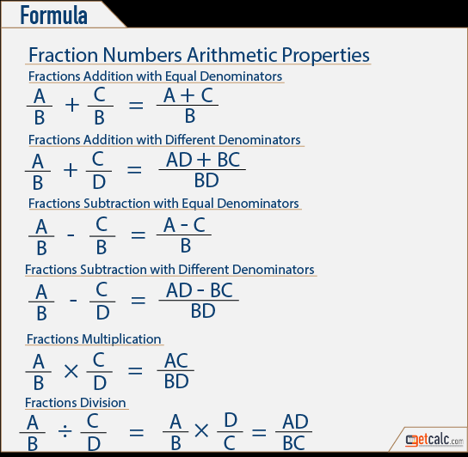

BASIC GEOMETRIC FORMULAS AND PROPERTIES

This handout is intended as a review of basic geometric formulas and properties. For further or more advanced geometric formulas and properties, consult with a SLAC counselor.

Square:

Perimeter: P = 4s or 2s + 2s

Area: A = s'

Rectangle:

Perimeter: P — 2w + 2f

Area: A = / x w

Triangles:

Perimeter: P = a + b + c Area: A = (1/2) x b x h

Types of Triangles:

Isosceles (two equal sides) Equilateral (all sides equal) Right (one 90° or right angle)

Pythagorean Theorem (for right triangles only):

a' + b' = c'

Sum of the Angles (all triangles):

A + B + C = 180°

